FUNCTIONS:

Typing in Quantities box, in customization window, is not adding it to shopping cart

* Open any Breakfast Salad or TOUCH-LESS MENU item, click customize
* If you type in 100 or any number in quantity box below, it still adds 1 to shopping cart

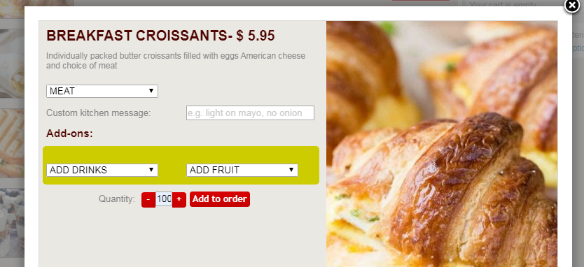

WHEN I CLICKED on ‘Touch-Less Covid-19 Menu’ (home page header) it highlighted Meal Prep as well(?)

* Problem is that Meal Prep needs different shopping cart (no minimum order, no delivery fee)
* NOTE: if you click on Meal Prep directly – then it works properly (and it should stay that way) – but when as described above that needs fix (to NOT activate Meal Prep)

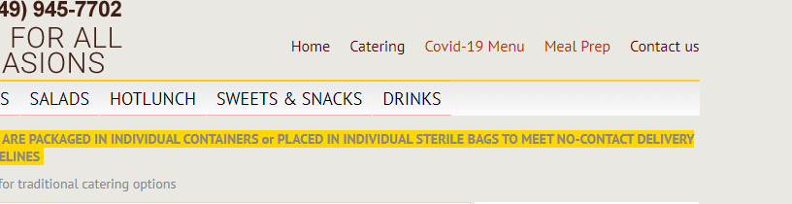

THIS POPUP NEEDS UPDATE

* Content inside (below) popup is outdated and needs change PUP UP CAFÉ is now:

**TOUCH-LESS CATERING**

With COVID-19 we took extreme measures and

fully implemented new standards to NO CONTACT

while cooking, and 100% CONTACT-LESS delivery

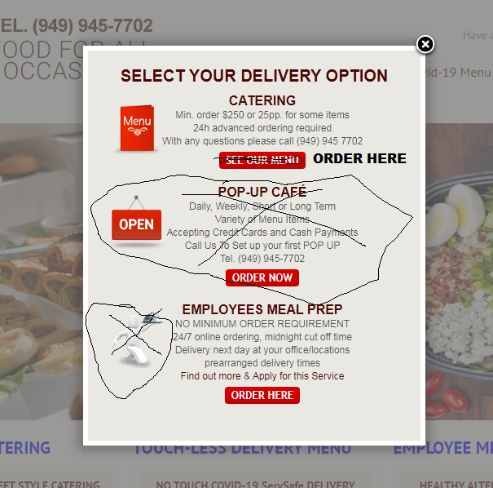

* **EMPLOYEES MEAL PREP** needs same FREE DELIVERY icon as on home page
* **SEE OUR MENU** button for TRADITIONAL (add traditional) CATERING change to ORDER HERE

HOTLUNCH - two words, change to HOT LUNCH

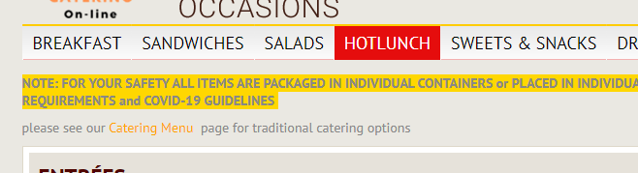

BULLET POINTS too close to Menu Icon, almost touching it, please increase spacing between Menu icon and bullet points

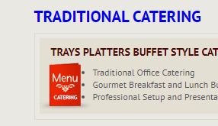

CHECKOUT NOT – NOT WORKING – NOT CHARGING CREDIT CARD

* I tried several different times, and was not able to order… This is very important please take a look below

